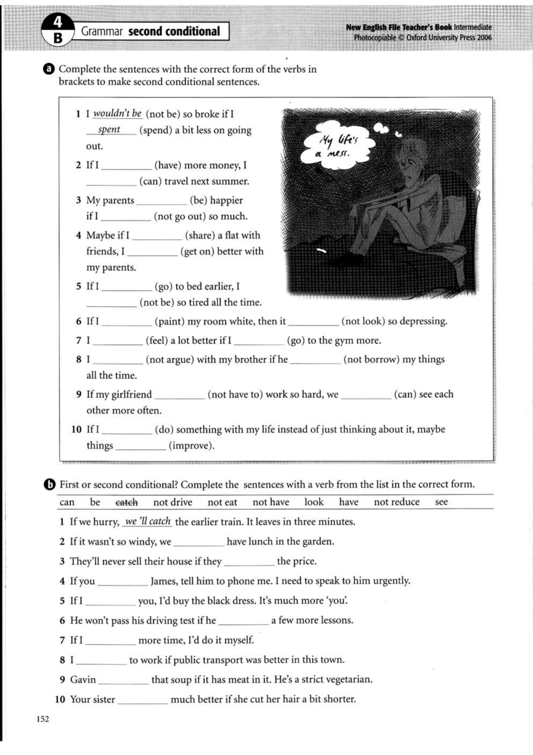

a)

2. had, would be able to

3. would be, didn’t go out

4. shared, would get on

5. went, would not be

6. painted, would not look

7. would feel, went

8. would not argue, didn’t borrow

9. didn’t have to, would be able to

10. did, would improve

b)

2. would eat

3. don’t reduce

4. see

5. were

6.

7. had

8. would not drive

9.

10. would look